Food vs. Predation? What drives mice populations in New Zealand beech forests.
or
Predator control does not always lead to mesopredator release. An example in New Zealand beech forests.
or
Clarifying the effect of top predator control on mesopredator dynamics in New Zealand beech forests.

Introduction

Introduced mammals, including stoats, rats, and mice, have major impacts in New Zealand’s (NZ) native forests primarily by consuming native plants and animals. To reduce these impacts, conservation managers regularly carry out control operations to reduce the size of populations of these pests.
Stoats (Mustela erminea) are the top predator in NZ forests and stoat control is undertaken to protect native birds vulnerable to predation, particularly hole-nesting species like mohua (Mohoua ochrocephala). However, the primary food source for stoats in NZ forests are rodents, especially mice, and there is concern that reducing stoat populations to protect native birds could allow rodent populations to increase, an undesirable outcome that could offset the benefits of stoat control because rodents are mesopredators that consume native invertebrates and the eggs and chicks of native birds. An important question is therefore: does stoat control lead to an increased abundance of rodents, particularly mice, in NZ forests?
Studies globally have shown that removal of a top predator often results in mesopredator release, which can lead to unexpected and often undesireable outcomes. While mesopredator release has been widely observed, it is unclear if stoat control will cause rodent populations to increase in NZ forests. Rodent populations respond strongly to variation in food supply, primarily seed availability, in NZ forests, with their populations irrrupting during years of high seed supply when forest trees mast seed, and declining in years of low seed supply. Stoats may be unable to exert sufficient top-down pressure through predation to prevent or slow these population irruptions. Blackwell et al. (2003) identified four ways in which stoats might regulate mouse populations:..... briefly describe these. They tested these ideas in a field study and found evidence that.....
More recently, attempts to model interactions between seed availability, mice, rats, possums and stoats in NZ forests have suggested that stoat control could allow rat populations to increase, which in turn might suppress mouse populations..... briefly describe the Tomkins et al findings.
Our aim in this study is to test the hypothesis that stoat control might allow mouse populations to increase in NZ forests by comparing mouse population dynamics in two catchments: one with stoat control and the second without..... describe the features of this study that make it a good test e.g. follow populations for several years to encompass irruptions and declines that allow you test the Blackwell et al. ideas. The study design includes rat control to allow you to test Tomkins et al. ideas that mouse outcomes might depend on interactions with rats..... Some of what you’ve written below could be incorporated into here, but keep it more direct and to the point

Mesopredator release is the removal of a top predator that leads to a lower-level predator (mesopredator) becoming more abundant. This has been identified as a major issue for conservation in marine, terrestrial and freshwater ecosystems globally. A common approach to quantifying mesopredator release is to construct a set of differential equations to define a multi-species population model (e.g. a Lotka-Volterra predator-prey model (LVPP)). By applying life history estimates to the proposed dynamics from relevant studies researchers can attempt to infer mesopredator release from the model projections. This approach has been applied to invasive mammals in NZ to incorporate the interactions between mice, ship rats (Rattus rattus; referred to as rats), possums (Trichosurus vulpecula) and stoats.
The LVPP models highlighted above all reviewed the relationship between food availability and the population increases of multiple invasive species. Results show that the secondary impacts of the other interacting invasive species can reduce the benefits of control operations, however, the overall effect may also be dependent on the thresholds of both direct and in-directly interacting species. More precisely, Tompkins and colleagues simulated different removal scenarios and found; 1. Stoat removal through trapping caused rats but not mice to increase in the subsequent year. 2. Removal of both rats and mice lead to lower numbers of stoats in the following years. 3. Mice numbers only increased during model simulations if rats or both rats and stoats were removed. Another simulation model that excluded possums found varying results, whereby; 1. Predators can delay but not prevent a prey eruption (phase one); 2. Predators cannot reduce prey abundance at their peak (phase 2); 3. Predators can hasten the rate of decline of prey populations (phase 3); 4. Prey populations are limited by predators at low abundances (phase 4) (Figure 1b).
Blackwell et al. (2003) tested the proposed phases of the LVPP model by controlling different predators in different areas and subsequently monitoring prey populations. Each phase was compared with two treatment types (predator removal or not) and two forest types (mixed beech forest and podocarp-tawa forest). The study concluded that in general predators may be able to slow, but not prevent prey eruptions. Limited evidence was found to suggest that the control of predators could significantly modify prey in the low (4), peak (2) or decline (3) phases. However, the geographical scale of the study and limited forest types meant the data did not provide enough information to compare different forest and treatment types for each of the four resource phases. The effects of stoat control on mice and rats is therefore still unknown in NZ beech forests.
Beech forests dominate at least half of NZ’s remaining native forests and are important habitats for many native species. Beech forests are defined as resource pulse systems, where “masting” is a spacially synchronised reproductive event that varies greatly between and within years. Beech trees have a strong impact on these forest systems because during masting years trees drop a significant amount of food in the form of seeds onto the forest floor. This finite food source is also synchronised with reproduction in many native species as well as invasive rodents (mice and to a lesser extent rats). All these species are potential prey for stoats but mice commonly dominate the diet.

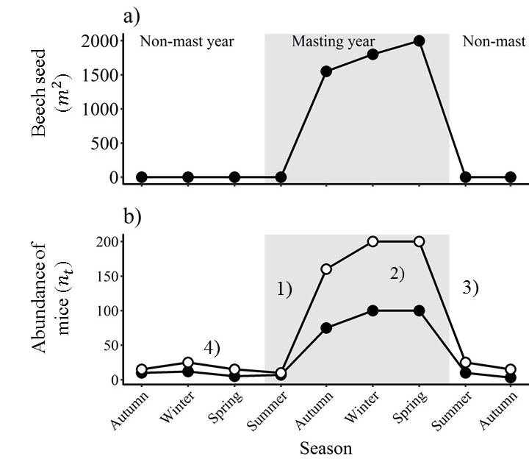
Figure 1: The top panel (a) shows the seasonal variation in available beech seed ($m^{2}$) between non-mast and mast years. The bottom panel (b) represents the responses of mice abundance ($n_{t}$) to seed variation in panel a) and the hypothesised effect of mesopredator release (full circles = stoats present; hollow circles = stoats absent). Each number represents a proposed phase to test mesopredator release; (1) is during increasing mouse abundance (summer to winter); the second phase (2) tests the difference at the peak of mice abundance (winter or spring). Three (3) investigates the declining mouse abundance (spring to summer) and the final hypothesis (4) tests the differences in mouse abundance in non-mast years.

This study tests the proposed outcomes of stoat control on mice dynamics in NZ beech forest. We have constructed a large-scale, control-before-after experiment in two independent ecosystems. A series of process models are proposed to encapsulate the multi-species interactions and the other known sources of variation from the literature. We then link the experimental data with the underlying ecological process models using a bayesian hierarchical structure. The best fitting process model is used to investigate the differences between areas with and without stoat control in the four different phases of mouse dynamics (Figure 1). We also test the effects of rats, mouse density and seed on the rate of increase. Our overarching objective is to provide a model framework that comprehensively assesses the effect of stoat control on mice dynamics in NZ beech forests. This research directly links the data to the proposed process models as a case study to further understand the generic responses of mesopredators in forest systems. This depth of understanding is vital as NZ embarks on a “predator free mainland”.

Materials and methods (past/present tense)

Study System and Specific Hypotheses
We carried out our study in beech forests in the South Island, where mice are the most abundant rodent species, rats (ship rats and kiore) are present but occur at lower abundance, and stoats are the main predator. To test whether reducing stoat predation on mice by stoat trapping affects mouse population dynamics we need to account for other factors known to influence mouse populations in this system. Beech seed is the primary food for mice in beech forest and mouse populations respond strongly to changes in seed availability both between and within years (Figure 1a). Between years, beech seed production is highly variable with little seed produced in most years and occasional years of substantial seed production (“mast” years; Figure 1a). Mouse populations remain low in non-mast years due to low food availability. In mast years, when seed becomes abundant, mouse populations can increase rapidly but show predictable fluctuations in response to seasonal changes in beech seed availability (Figure 1b). Seed begins to fall in late summer and begins to accumulate on the forest floor, allowing mouse populations to increase from late summer onward, with mouse populations typically remaining high through winter and into the following spring. Beech seed that isn’t consumed by mice then germinates in spring to early summer, meaning this food resource disappears and mouse populations then decline to low levels if the following year is a non-mast year and no further seed becomes available.
These predicatable seasonal fluctuations in mouse abundance lead to four hypotheses regarding how stoat control might impact mouse populations during different phases of the beech seed cycle (Figure 1b; stoat control (hollow circles)); 1) Stoat removal could increase the rate at which mouse populations initially increase during mast years in response to high seed availability in late summer; 2) Stoat predation could result in lower peak abundance of mice; 3) Stoat predation could hasten the rate at which mouse populations decline from peak abundance; 4) Stoat predation could reduce mouse populations in non-mast years when food availability is low. To examine the degree to which stoat removal might impact mouse populations we test each of these four hypotheses.
Two additional factors affecting mouse populations need to be accounted for. First, in addition to competing for food, mice are known to be regulated by other unidentified density dependent processes. It is not clear what these density dependent processes are but are an important component of mice dynamics. Second, rats may influence mouse populations via competition, because rats and mice have overlapping diets, or possibly through direct predation. Previous studies in mixed podocarp forest have shown that reducing rat populations can allow mouse populations to increase, but it is unclear whether this occurs in beech forest where rats tend to occur at lower densities. Modelling suggests that this is a possibility.
We used data on changes in seed availability, and mouse and rat abundance, through time (see below) to calculate the rate of change in mouse populations between seasons as our response variable, and constructed a model that linked this rate of change to the processes described above. The rate of increase of mice ($r_{mice}$) was estimated as (see appendix for further details):
$$r_{mice}=β_{0}+β_{1}\left({seed}_{t}\right)+β_{2}\left({mice}_{t-1}\right)+β_{3}\left({rats}_{t-1}\right)$$ | (1)

Where $β_{0}$ is the overall model intercept, which is equivalent to $r_{mice}$ when all other parameters are set to zero; $β_{1}$ is the adjusted* effect of a single unit change of beech seed ${(seed}_{t})$ on $r_{mice}$; $β_{2}$ is the adjusted* effect of a single unit change in mouse density at the beginning of the previous season (${mice}_{t-1}$) and $β_{3}$ is the adjusted* effect of a single unit change of the minimum number of rats alive (MNA) at the beginning of the previous season (${rats}_{t-1}$).
The differences between the stoat controlled and uncontrolled areas were compared for each parameter. If stoat predation is sufficiently high to impact mice populations, we propose that the removal of stoats would cause mesopredator release of mice. If mesopredator release occurs in the “increase phase" (hypothesis one); the intercept ($β_{0})$ for the areas with stoat control with be greater than the uncontrolled areas and all other parameters will be equal. The opposite will be true for the decrease phase (hypothesis three). Hypothesis two and four investigate the peak and troughs of mice populations. At these times, stoats could further limit mouse abundance by removing individuals through predation. To test the differences in rat interactions and mouse density at different phases we use the same parameterization within each phase.

Data
The data were collected from eight independent grids, located in two isolated valley systems in Fiordland National Park, South Island, NZ (Eglinton Valley (44°2’ S, 168°5’ E) and the Hollyford Valley (44°4’ S, 168°1’ E). The Eglinton Valley is dominated by Red Beech (Fuscospora fusca) at low altitudes (approx. 450 m a.s.l.) where the trapping grids were located and mountain beech (Fuscospora cliffordoides) at higher altitudes. There is some silver beech (Lophozonia menziesii) throughout the valley. The annual rainfall is approximately 2300mm, and in winter months some snow falls. The Hollyford Valley comprises a mixed silver beech–hardwood–conifer (kamahi, broadleaf, rimu, miro, matai, kahitea) forest with a more complex understorey of shrubs and ferns. Annual average rainfall is approximately 4250mm at 180 m a.s.l. The two valleys run north-south and are separated by the Southern Alps. Study sites in the Eglinton Valley are approximately 35km from study sites in the Hollyford Valley. Four independent grids were set up in each valley to collect data.
Data were collected on rats, mice, kiore (Rattus exulans) and seeds quarterly from May 1999 to February 2004 (20 trips), corresponding to the four seasons (May = Autumn, August = Winter, November = Spring and February = Summer). The following disparities occurred in data collection; data was reduced to three grids in each valley after November 2002 to focus on capture-recapture (CR) and a before/after treatment (before = no stoat control, after = stoats controlled) in the Hollyford Valley. Due to unfavourable weather restrictions that would impact capture rates; a minimum of three nights trapping was undertaken, with most trips consisting of four or more trapping days. The total length of a single trip did not exceed nine days apart (average 4.5 days).
Available beech seed (referred to as seed from here onwards) was measured at each grid using two standard circular seed-traps each with a collecting area of 0.125 $m^{2}$, set 1.2 metres above the ground and covered by wire netting to preclude seed predators. Seed-trap contents were collected during each trapping session (n = 20) and beech seeds with a kernel were recorded and used to estimate the amount of seed per metre squared ($Seed m^{2}$).
Rodent populations (kiore, rats and mice) were monitored using Elliot traps and the removal of rats occurred on two of the grids as a rat removal treatment. On each of the grids, 81 traps were set (9*9), 20 metres apart covering a total area of 2.56ha (25 600 $m^{2}$) per grid. All animals caught on CR grids were given an ear notch to indicate the trapping session during which they were first encountered. Mice had single notches and rats were double ear tagged with individually numbered ear tags. Data were collected on; grid location, tag number and notch position. Both rat and kiore captures were low throughout the study and even the combined recaptures did not allow for a robust CR model to be constructed. Therefore, rat interactions were measured as the minimum number of rats and kiore combined (${MNA}_{t}= N_{t}+1+(0.05N_{t})$). This is equivalent to the total number of new animals over a five-night trapping period.
All intentionally trapped stoats were removed using Fenn traps. 751 stoats were removed from the Eglinton Valley during a pest control program between May 1999 and June 2001. Some rats were removed as by-catch in stoat traps but no other pest control was conducted. Removal of stoats was also conducted as a before/after treatment in the Hollyford Valley after May 2002. This program removed 13 stoats. Incidental stoat captures during the routine rodent trapping sessions were recoded in the two valleys (Hollyford Valley total 20, Eglinton Valley total eight stoat captures).

Statistical Analysis
To estimate the population abundance of mice ($n_{t}$) at each grid(j) and trip(k) we estimated a population size as $N_{j,k}$, from the capture recapture history for each observed individual ($Y_{i,j,k}$). This was assumed to be draw from a binomial distribution with a mean of $μ_{i,j,k}$ and the variation was conditional on the total number of days in each trip ($J_{i,j,k}$; due to varying lengths of each trip). $μ_{i,j,k}$ was assumed to be dependent on both the probability of capture for a single individual mouse ($p_{i,j,k}$) and the probability that individual was also observed ($z_{i,j,k}$) in that grid and trip. We augmented $z_{i,j,k}$ over 4x the total number of individuals observed in each trip and grid to estimate the true abundance ($N_{j,k}$). To account for individual heterogeneity between grids (j) and trips (k), we model individual capture probability ($p_{i,j,k}$) as coming from an overall normal distribution with the same mean (${μ.ind}_{j,k}$) for each trip and grid. We then allowed ${μ.ind}_{j,k}$ to also vary between individuals ($μ_{p} \& τ_{p}$).

$$y_{i,j,k}∼Binomial\left(μ_{i,j,k}, J_{i,j,k}\right)$$
$$μ_{i,j,k} \sim z_{i,j,k}×p_{i,j,k}$$
$$z_{i,j,k}∼Bernoulli\left({psi}_{j,k}\right)$$
$$logit\left(p_{i,j,k}\right)={lp}_{i,j,k}$$
$${lp}_{i,j,k}∼Normal\left({μ.ind}_{j,k}, τ.ind \right)$$

$${μ.ind}_{j,k}∼Normal\left(μ_{p}, τ_{p}\right)$$
$μ_{p}$ ~ $Normal\left(0, 0.00001\right)$
$$τ_{p}= \frac{1}{(σ_{p} × σ_{p})}$$
$$σ_{p} \sim Uniform(0,10)$$

$${psi}_{j,k} \sim Uniform(0,1)$$

$$N_{j,k} \sim \sum{z_{i,j,k}}$$

To estimate the rate of increase of mice ($r_{j,k}$) and include the uncertainty around the abundance estimate ($N_{j,k}$) we used the complete data likelihood. This was done by taking the abundance estimate ($N_{j,k}$) and an additional parameter ($γ_{j,k}$) to determined which individuals are from the augmented parameter space and are also individuals of interest ($ρ_{j,k}$) by imposing a binomial prior distribution on${ π}_{j,k}$. This method was adapted from fitting these models in BUGS. We then transformed $ρ_{j,k}=r_{j,k}+ ρ_{j-1,k}$ to find the rate of increase of mice at each grid and trip ($r_{j,k}$; note the first trip in each grid can’t be estimated).

$$∅_{jk}∼Bernoulli\left(π_{j,k}\right)$$
$$π_{j,k} \sim Poisson( N_{jk},γ_{jk})$$
$$\log\left(γ_{jk}\right)=ρ_{j,k}$$
$$ρ_{j,k}=r_{j,k}+ ρ_{j-1,k}$$

$$ρ_{1,k}∼Normal\left(μ.lam, tau.lam \right)$$
$$μ.lam∼Normal(0,0.00001)$$
$$tau.lam=\frac{1}{(σ_{lam} × σ_{lam})}$$
$$σ_{lam}=Uniform\left(0,100\right)$$

The process model is then fitted to $r_{j,k}$ for each season and valley.

$$r_{j,k} \sim Normal\left({μ.r}_{\left[valley\left(j\right)\right],\left[season\left(k\right)\right]},τ_{r}\right)$$
$${μ.r}_{\left[valley\left(j\right)\right],\left[season\left(k\right)\right]}=β_{0\left[valley\left(j\right)\right],\left[season\left(k\right)\right]}+β_{1}{seed}_{\left[valley\left(j\right)\right],\left[season\left(k\right)\right]}+β_{2}{mice}_{\left[valley\left(j-1\right)\right],\left[season\left(k\right)\right]}+β_{3}{rats}_{[valley(j-1)],[season\left(k\right)]}$$

It is possible that mice abundance may respond to seed availability in a range of ways (${seed}_{\left[valley\left(j\right)\right],\left[season\left(k\right)\right]}$). To account for this, we fitted three different functional responses (g(F)) from previous studies of mice in NZ beech forests:

1) The unmodified seed data ($g\left(F\right)=c1×s{eed}_{j,k}$; a Type I direct linear relationship of seed consumption to mice).
2) The natural logarithmic of the seed ($g\left(F\right)=c1 ×\log\left(s{eed}_{j,k}\right)$; a Type II response of mice to seed).
3) The Holling Type II (Ivlev equation; Ivlev 1961) fitted by Ruscoe et al. (2005) to experimental data in the Eglinton Valley, $g(F)= 1042.1×(1- e^{\left(-\left(s{eed}_{j,k}×0.00139\right)\right)})$.

Models were assessed using two measures of fit; R-squared and AIC. AIC is a test of parsimony in models (a measure of the trade-off between model complexity and model fit). Low AIC values imply the best-fitting model relative to the full cohort of fitted models. The r-squared ($r^{2}$) value represents a goodness-of-fit test, that is, how much variation in the response variable ($r_{j,k}$) was explained by the predictors (density, rats and beech seed). R-squared values closest to one imply that the regression line fits the data well and lower values represent poor fitting models.
Models were fitted in a Bayesian framework using Markov Chain Monte Carlo (MCMC) methods and implemented in JAGS, called from R v.4.3.4 using the jagsUI package. Each coefficient was modelled with uninformative priors for each season and valley. We specified non-informative priors to allow the data to drive parameter estimation. Each model was run for 100000 iterations with a burn-in of 50000 iterations, which was sufficient to achieve convergence as judged by visual inspection of the chain histories. For a full model description see Appendix 1.
The model coefficients ($β_{0}$, $β_{1}$, $β_{2}$ and $β_{3}$) allowed us to test hypothesis one and three, where each parameter represented the adjusted* effect at the overall intercept (rate of increase of mice), seed, mouse density and rats respectively. We tested the differences in $r_{j,k}$ at the low (phase 4) and high (phase 2) mouse abundance in areas with and without stoat control using a two-way analysis of variance (ANOVA) to account for variation in grids, trips and valleys. For hypothesis two we compared the abundance of mice after accounting for seed ($\frac{abundance (n_{t})}{seed (m^{2})}$) and for hypothesis four we directly compared the abundance of mice$(abundance (n_{t})$) using analysis of variance to account for differences in sample size, trips and grids.

* Adjusted refers to the model parameters being estimated after accounting for all other parameters in the process model (Model 1).

Results
Beech seed fluctuated between years (Figure 2a), with some years having high seedfall (2000, 2001 and 2004; mast years) and other years having much lower seedfall (1999, 2002, 2003; non-mast years). Rodent populations (mice and rats) displayed a defined and synchronised response to seasons with corresponding increases in food availability (Figure 2b & c). Mouse abundance ($n_{t}$) was greatest in the Eglinton Valley (hollow triangle symbols) and rat numbers (MNA) remain relativity low in this valley throughout the four-year study expect for a single trip in Spring 1999. In the Hollyford Valley during both mast-years, rats increased irrespective of stoat control (Figure 3c). The smallest amount of seed during a mast year was recorded the Eglinton Valley in 2004 and no rats were captured after May 2002 in this valley (rats did not appear to respond to seed). Although these trends are suggestive of the underlying patterns, there are confounding relationships between seed, mouse density and rats that occur independent of stoat control. It is also vital to quantify the true variation between grids (variation around mean estimates) and within each season (variation between trips) to correctly interpret the observed differences in areas with and without stoat control.
Model 1 defines the underlying relationship between the rate of increase of mice and the known factors that influence mice dynamics. We then fitted this model to three different functional responses. Both model fit, and model selection methods indicate that the best model accounts for seed using the log transformed seed data (Type II; log(seed)). The best fitting process model (full output in Appendix A2) was then used for the remaining analysis.

Table 1: Estimates of model fit using three possible functional responses of mice to available seed as a function of the rate of increase of mice populations. All models account for mice density and competition from rats. Overall model fit with values closest to 1 represent better fitting models ($r^{2}$) and lower values of AIC indicate the best model from the selected cohorot.
Functional response | Overall fit  ($r^{2}$) | Model selection  (${AIC}_{i}$) | AIC weights  (${AIC}_{w}$)
log(seed) | 0.76 | -201 | 1
IR | 0.67 | -159 | 0
seed | 0.51 | -99.0 | 0

Overall across all parameters there was no significant difference in the rate of increase of mice populations ($r_{mice}$) between the two valleys or in areas with and without stoat control (differences in parameter estimates between valleys and control areas all included zero; Appendix 2). Seed had a positive effect on $r_{mice}$ in all seasons ($μ\left(β_{1}|Spring-Summer\right)$ = 0.25, $μ\left(β_{1}|Summer-Autumn\right)$ = 0.52, $μ\left(β_{1}|Autumn-Winter\right)$ = 0.66, $μ\left(β_{1}|Winter-Spring\right)$ = 0.44) and the average effect size was always greater than both density and rat effects. Mouse density generally had a negative effect on $r_{mice}(μ\left(β_{2}|All seasons\right))=-0.011)$ but the variation was greater relative to the mean** than seed ($μ\left(β_{2}\left(SE\right)\right)= 0.007, CV=0.63 vs μ\left(β_{1}\left(SE\right)\right)=0.474, CV=0.40$). The effect of rats on $r_{mice}$ had the smallest average effect size $(μ\left(β_{2}|All seasons\right)= 0.007)$ and was the most variable parameter ($μ\left(β_{3}\left(SE\right)\right)= 0.044, CV= 5.74$). Figures 3, 4 and 5 visualise these results and the four hypotheses in more detail.

**A measure of overall variation after accounting for the effect of the mean estimate is often referred to as the Coefficient of Variation (CV=$\frac{SE}{mean}$)
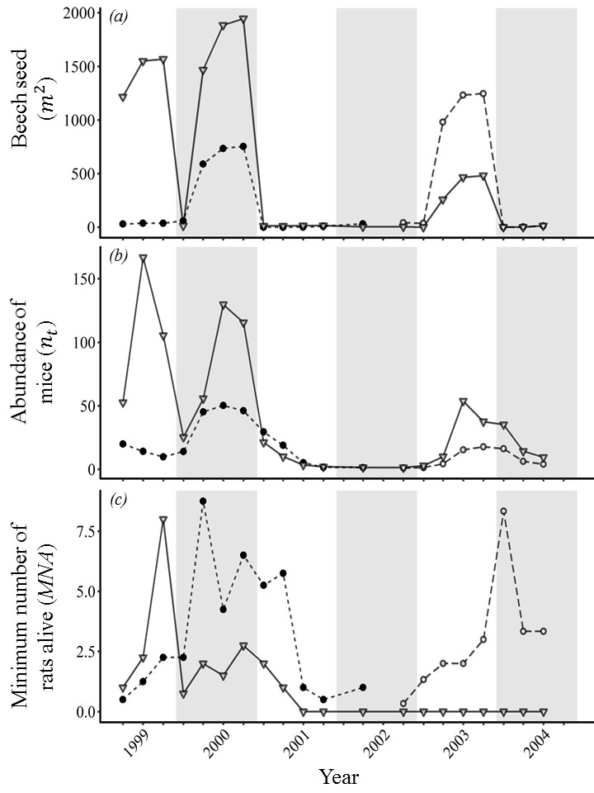
Figure 2: [The three plots above represent the average (point estimates) of the data collected each season (ticks on x-axis) during the study period (Autumn 1999 to Winter 2004). The shape difference distinguishes the two valleys apart (triangle = Eglinton Valley, circle = Hollyford Valley). The solid symbols represent cases where stoats are uncontrolled and hollow symbols in valleys with stoat removal. Plot a) is the accumulative beech seed per metre squared (Seed ($m^{2}$)), b) is mouse abundance ($n_{t}$) estimated from the capture-recapture model, and c) is the minimum number of rat’s present (MNA).]

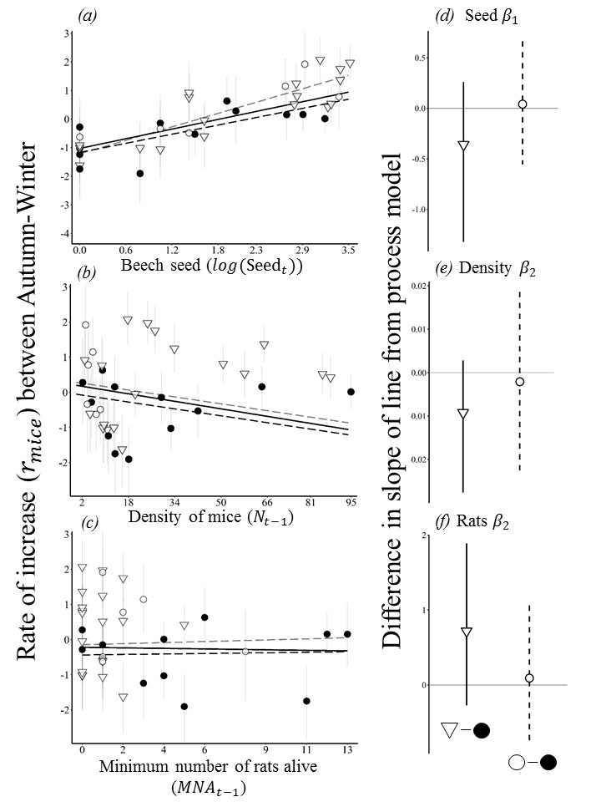
Figure 3: [Visual representation of the effect of stoat control during the increase phase (Autumn to Winter; hypothesis one). The left column represents the untransformed estimates of seed ${seed}_{t}$ (a), mouse density ${mice}_{t-1}$ (b) and MNA of rats ${rats}_{t-1}$ (c) in relation to rate of increase ($r_{mice}$). The right-hand column is the corresponding parameter estimate from the process model. The shape difference distinguishes the two valleys (triangle = Eglinton Valley (E), circle = Hollyford Valley) and the solid symbols represent cases where stoats are present and absent at points with hollow symbols. Parameter estimates (d,e,f) represent the differences in stoat control between valleys (left; hollow triangle) and within valley (right; hollow circle).]

Hypothesis one tested whether stoats can limit the rate of increase in mice populations during the seed production phase (Figure 1; 1) Summer-Autumn-Winter). Figure 3 only uses the phase with the strongest observed increase in mice populations (Autumn to Winter; $μ\left(β_{1}\right)$ = 0.66). In accordance with other studies, there was a strong positive trend between rate of increase ($r_{mice}$) and seed where greater amounts of seed results in high rates of increase (Figure 3a; left column). This was supported by the fitted process model that accounted for other variables (Figure 3; Seed ($β_{1}$)). There was no difference in stoat control overall, represented as the difference between estimates of the model intercept ($β_{0}($stoat control) – $β_{0}$(no stoat control) = -0.44 (95% CI -1.63 – 0.76)) both between (Figure 3d; triangle) or within the same valley system (Figure 3d; circle). None of the other parameter estimates suggested any differences either ($β_{1}$, $β_{2}$ and $β_{3}$, indicated from the overlapping 95% credible intervals; Figure 3; right column). Mouse density and rat indices had a much low effect sizes compared to seed.
Hypothesis three specifically focuses on the declining phase of mouse dynamics. As expected, this phase has lower amounts of seed present than the increasing phase (Figure 3a vs Figure 4a). During this phase (Spring to Summer), rodent populations are crashing. Density has a weak negitive effect under all conditions (Figure 3b) but is much stronger during the declining phase of mice dynamics. After accounting for seed and density in the process model there was a faster rate of decline in the Hollyford Valley (dashed lines) compared to the Eglinton Valley (Figure 4b) but was not significant (Figure 4e). The variation in the rat index was similar in both valleys. The highest estimate of rats was in the Hollyford Valley with stoat’s present, but all other high records are in areas with stoat control however this did not have a significant effect on overall process model (Figure 4f).
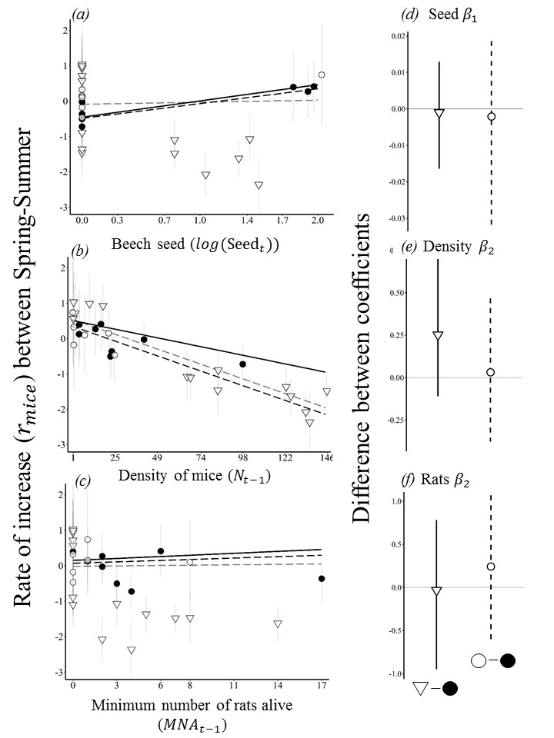
Figure 4: [Results for the effect of stoat control during the decreasing phase (Spring to Summer; hypothesis three). The left column represents the untransformed estimates of seed ${seed}_{t}$ (a), mouse density ${mice}_{t-1}$ (b) and MNA of rats ${rats}_{t-1}$ (c) in relation to rate of increase ($r_{mice}$). The right-hand column is the corresponding parameter estimate from the process model. The shape difference distinguishes the two valleys (triangle = Eglinton Valley (E), circle = Hollyford Valley) and the solid symbols represent cases where stoats are present and absent at points with hollow symbols. Parameter estimates (d,e,f) represent the differences in stoat control between valleys (left; hollow triangle) and within valley (right; hollow circle).]

Hypothesis two investigates whether stoats can limit mouse populations at high abundance during masting phases. We compared mouse abundance after accounting for seed availability; $\frac{abundance (n_{t})}{seed (m^{2})}$ because increased food is directly correlated with abundance. Overall there were less replicates in the Hollyford Valley in the stoat control treatment. After accounting for differences in sample size and variation within groups there was no difference between the stoat controlled and uncontrolled areas (p-value = 0.423; 95% CI -4.631 – 10.558). But there was a significantly lower relative abundance in the Hollyford Valley compared to the Eglinton Valley (p-value < 0.003, 95% CI -19.098 – -4.484).

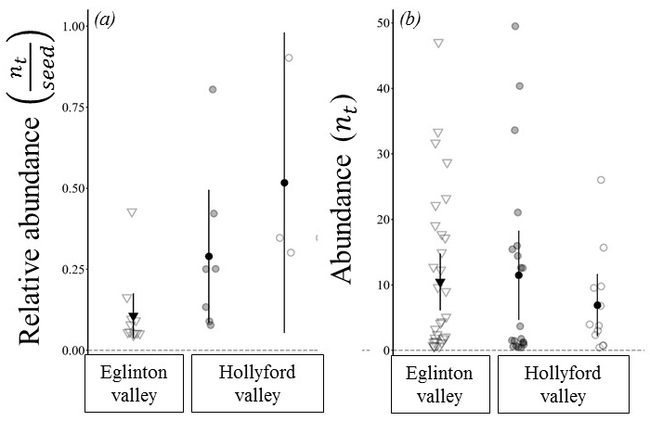
Figure 5: [Hypothesis two (a) compares the relative population size of mice (mouse seed divided by abundance) at the peak phase (mast-years, varying seasons). Hypothesis four (b) focuses on the unmodified abundance of mice in non-mast years (low abundance phase). The shape difference distinguishes the two valleys (triangle = Eglinton Valley (E), circle = Hollyford Valley) and the solid symbols represent cases where stoats are present and absent at points with hollow symbols.]
Hypothesis four investigates the low abundance phases of mouse dynamics. We did not account for seed availability in this assessment due to many estimates being equal to zero. Variation in mouse abundance was similar between both ecosystems. After accounting for variation within and between groups (ANOVA) there was no significant difference between valleys (p-value = 0.396, 95% CI -4.384 – 13.524). And no difference between area with and without stoat control (p-value = 0.311, 95% CI -11.846 – 4.754).
Overall there is little difference between the controlled and uncontrolled areas in relation to mice dynamics. We compared four phases of a resource pulse system where ecosystem theory suggests mesopredator release could occur in NZ beech forest and found no evidence to suggest mesopredator release of mice after the control of stoats. Additionally, there appeared to be no identifiable interaction effect between rats and mice.

Discussion
Understanding the processes that regulate populations of interacting species has historically focused on the consequences of predator-herbivoure interactions but predators (e.g. stoats) also regulate lower-level predators (e.g. mice). Recently (1989-2009), more than 95% of published studies relating to mesopredators reported evidence of either mesopredator release or suppression and generally, changes in predator abundance can have a 4-fold greater impact on mesopredators. In the light of this we investigated three interacting invasive species (mice, rats, stoats) in native NZ beech forest.
The experimental design allowed us to collect direct evidence of differences in mouse abundance (and subsequently $r_{mice})$between areas with/without stoat control and between similar but independent ecosystems. We estimated $r_{mice}$ from mouse abundance in eight replicated grids. The associated effect sizes of beech seed, density and rats on the rate of increase of mice ($r_{mice}$) were estimated for each unique resource phase, valley and treatment type (stoat control). The overall process model (Model 1) was fitted to the data using three different functional responses and the best model was selected after checking diagnostics and overall model fit (AIC and $r^{2}$).
Our results verified previous studies that found mice respond strongly to beech seed availability (resource pulse) and are regulated by underlying intraspecific density dependant mechanisms in all phases of the masting cycle. Analogous predator-prey (LVPP) models are not directly comparable because some do not include a resource component or use indices. Field studies also use structurally different ecosystems, species indices or dont report effect sizes. Generally, all models concluded that beech seed has the greatest impact on mice populations and this is strongest during the phases of increasing beech seed ($μ\left(β_{1}\right)= 0.474$). That is, on average when all other parameters are zero, a single unit increase in log$(seed m^{2})$ between autumn-winter, will result in a 0.474 in $r_{mice}$. By calculating the maximum increase from the fitted process model and the data (density + rats = 0;. $({Rmax}_{mice}= r_{mice|\max\left(seed\right)=2648}=-0.489+0.474*\log\left(2648\right)= 3.25)$ we are able to compare the maximum population growth rate to other studies (${Rmax}_{mice}$). Our estimate is below the maxiumum population grow rate (${Rmax}_{mice}$) of other studies (example see) verifiying that the outputs are biologically viable. The effect of mouse density and rats on $r_{mice}$ was much lower and were also similar to other published results. However, by taking the proposed processes that effect mice dynamics and applying a hierarical model framework allows us to test and estimate effect sizes that further reduce uncertianty in the outcomes of predator control in NZ beech forests.
In contrast to other studies we found no evidence of differenting population dynamics between mice in areas with or without stoat control. Generally, strong resource pulses cause strong effects throughout an ecosystem. This may be why we see little effect of stoat removal on populations of mice. The proposed biological reasoning for this phenomenon is that even in the absence of control, stoats cannot attain high enough densities to limit mouse populations. Furthermore, differences in the reproductive and intrinsic growth rates (life history traits) of each species reduces the ability of stoats to regulate mouse populations.
A alternative reason for the lack of observed increases in mouse abundance may have been a result of the effectiveness of stoat control. If trapping did not remove 100% of individuals or reduce mouse populations to low enough to reduce predation pressure. High individual heterogeneity in stoats at both high and low mouse densities can result in reductions to zero being vertically impossible targets. This was the case in our study where by-catch of stoats in controlled areas was observed. As an indication of removal, 4.75 times more stoats were removed from the stoat control program (Hollyford 2001-2004) than caught in by-catch in areas already being controlled (Eglinton 2001-2004). Total predator removal was not achieved in this study; however, it does represent a realistic representation of “stoat control”. Similarly, the removal of other pests through by-catch in traps could have had an effect on mice dynamics but the scale of trap line (size) and the relatively small home ranges of rodents compared to stoats suggests that population level impacts from these removals across multiple replicates is very unlikely.
Contrary to laboratory and field experiments we found no significant interaction between rats and mice. Our results suggest that it is unlikely that rats have strong impacts on$r_{mice}$ overall at the ecosystem level in NZ beech forests. Previous laboratory experiments suggested that interactions between mice and rats were negatively related to predation or competition effects based and evidence of competition release has been observed in mixed podocarp-tawa forests in NZ. Furthermore, a naive investigation of our data might have falsely identified rats as having an effect in the raw data (Figure 2c), but after accounting for seed and mice density, the overall effect size was small and the uncertainty was large. In part, this is due to the high variation in the number of rats and kiore between grids in our study. Instead of rats/kiore being present but at low numbers in all grids (low effect size and low uncertainty), there were only a few grids that had comparability high indices and many other replicates with very low indices. This may indict refugee areas that can support larger rodents in pure beech forests. Overall, it is likely that beech forests do not have enough resources to support larger spatially uniform populations of rats.
Population level responses such as abundance and rate of increase are often measured using indices (e.g. MNA). This can lead to difficulty in estimating population level parameters such as density. We have reduced this bias for mice by using capture-recapture (CR) data and an integrated population model to correctly account for errors in abundance estimation when fitting the process model of mice dynamics. However due to limited population numbers and data, only indices were used to represent rat interactions. Independent research in beech forests has shown a high correlation between indices of rats in this valley and CR data. Increasing the quality of the rat/kiore data would reduce uncertainty in these parameter estimates.
Two important aspects of this ecosystem that we do not expected to follow the same results as presented here are differences in forest structure and the effects of climate change on future mice dynamics. Mice populations monitored in more complex forest ecosystems highlight the interactions between top-down and bottom-up effects. These studies suggest that rodent populations would increase in other NZ forest ecosystems after the removal of stoats or other invasive predators. LVPP models used to model climate change indicate a shift to prolonged but lower overall mast events where it may be possible to observe mesopredator release of mice with the removal of predators.
Our integrated population modelling approach and the large, high-quality CR data used to parameterise the model allows us to predict and report the biologically relevant effect sizes in this paper. Our results can now be tested and assessed using the same model (Appendix 3; GIT reference) or against other model parameterisations. Many of the processes we have verified were previously hypothesized using indices of mice abundance, laboratory experiments, novel systems such as remote islands and small patches of mainland forest. We have integrated these results into a framework that can now test these results in other systems that are hypothesized to be different. It will be important for future work to continue monitoring this system for anomalies and unexpected patterns such as increases in other pest species, particularly rats. The need for in-depth and long-term data collection to be able to identify the importance of multiple interacting factors in multi-pest dynamics. This study clarifies that mesopredator release of mice in response to stoat control is unlikely to occur at the ecosystem level in NZ beech forests.

Second option Figure two
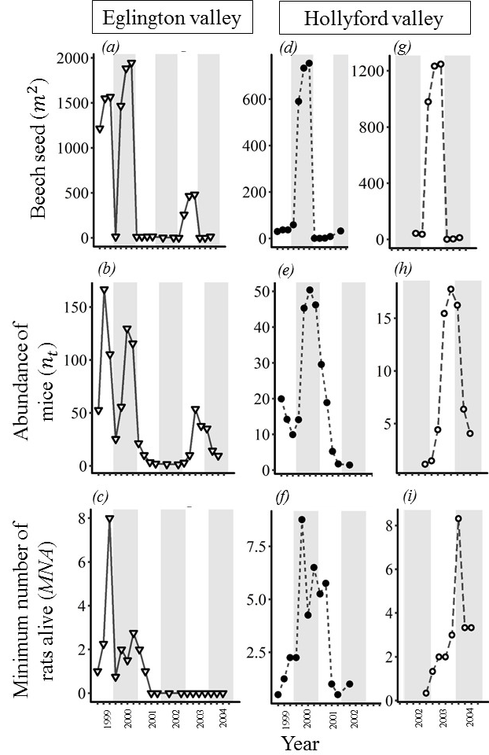
Figure 2 […]

